**Human Resource Plan**

**<Garage Apartment Construction>**

**Corey Crooks**

**Purdue University Global**

**IT401 Project Management II**

**Steven Long**

**October 25th, 2023**

**Table of Contents**

Introduction 2

Roles and Responsibilities 2

Project Organizational Charts 3

Staffing Management 4

# Introduction

This section explains the purpose and importance of having a human resources management plan. It should provide a general description of what the plan includes and explain how the project manager and project team can use the plan to help them manage the project effectively.

# Roles and Responsibilities

|  |  |  |  |
| --- | --- | --- | --- |
| **Role** | **Authority** | **Responsibility** | **Competency** |
| Project Manager | Project Wide | Milestone Development, and Stakeholder Engagement | Project Management, Logistics Specializations, Stakeholder Communications |
| Documentation Specialist | Logistics and Planning | Planning and Resourcing | Documentation Organization, Inter-Contractor Communications, Milestone Diagramming |
| Construction Specialist | Physical Construction, Electrical Organization, Water Access, and Outdoor Spaces | Oversee Physical Materials Handling and Construction Project Milestones. | Project Management, Documentation Organization, Knowledge of Project Requirements |
| Carpenter | Physical Construction | Construction and Equipment | Blueprint Assessments, Hardware Procurement, Construction Designation |
| Electrician | Electrical Organization | Running Electronics, Proof of Safety | Electronic Assembly, Diagramming, Hardware Communication |
| Designer | Layouts and outdoor spaces | Design and Assemble the Accent Spaces Outdoors | Designer Drafting, Artistic Communications, Physical Assembly |
| Plumber | Water Accesses | Connect plumbing to fixtures that need them | Plumbing Assembly, Mapping, Permit and Regulation Organization |
| Quality Assurance | Documentation | Ensure Standard of Quality for Building and Project. | Documentation Organization, Inter-Personnel Communications, Stakeholder Communications |

**Project Manager (PM), (1 position):** responsible for the overall success of the Software Upgrade Project. The PM must authorize and approve all project expenditures. The PM is also responsible for approving that work activities meet established acceptability criteria and fall within acceptable variances. The PM will be responsible for reporting project status in accordance with the communications management plan. The PM will evaluate the performance of all project team members and communicate their performance to functional managers. The PM is also responsible for acquiring human resources for the project through coordination with functional managers. The PM must possess the following skills: leadership/management, budgeting, scheduling, and effective communication.

The assigned project manager will be Corey Crooks.

# Project Organizational Charts

This section provides a graphic display of the project tasks and team members. The purpose of this is to illustrate the responsibilities of team members as they relate to the project tasks. Tools such as responsible, accountable, consult, inform (RACI) or responsibility assignment matrix (RAM) may be used to aid in communicating roles and responsibilities for the project team. Additionally, organizational or resource breakdown structures may be used to show how responsibilities are assigned by department or by type of resource respectively. It should be noted that the level of detail may vary depending on project complexity.

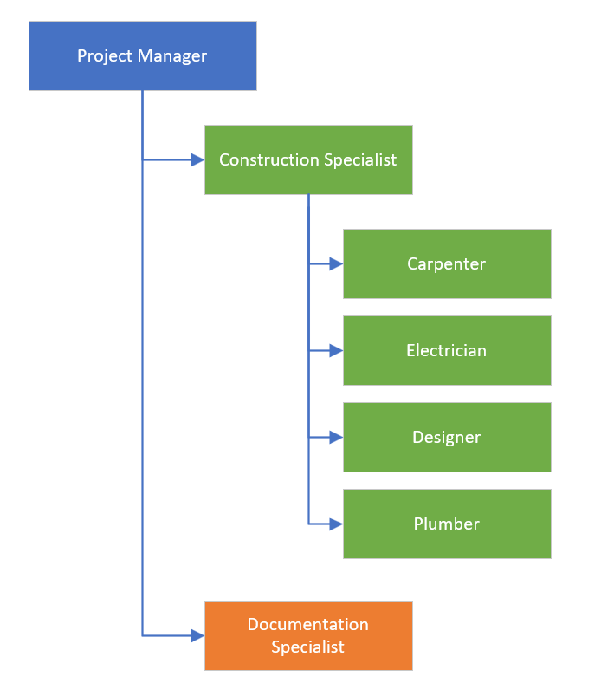

The following RACI chart shows the relationship between project tasks and team members. Any proposed changes to project responsibilities must be reviewed and approved by the project manager. Changes will be proposed in accordance with the project’s change control process. As changes are made all project documents will be updated and redistributed accordingly.

|  |  |  |  |  |  |  |  |
| --- | --- | --- | --- | --- | --- | --- | --- |
|  | Project Manager | Construction Specialist | Documentation Specialist | Carpenter | Electrician | Designer | Plumber |
| Develop Project Charter | A | A | R |  |  | C |  |
| Develop Project Plan | A | C | R |  |  | C |  |
| Design Floorplan | I | A | R |  |  | A |  |
| Construct Garage | I | A | I | R | R |  |  |
| Furnish Areas | I | I | A |  |  | R | R |
| Design Landscapes | I | I | I | C |  | R |  |
| Document Project Successes | A | I | R |  |  |  |  |

Key:

R – Responsible for completing the work

A – Accountable for ensuring task completion/sign off

C – Consulted before any decisions are made

I – Informed of when an action/decision has been made

# Staffing Management

This section contains information on several areas including: when and how human resource requirements will be acquired, the timeline for when resources are needed and may be released, training for any resources with identified gaps in skills required, how performance reviews will be performed, and the rewards and recognition system to be used. It is important to note that depending on the scope of the project there may be other items included in staffing management (government and/or regulatory compliance, organizational health and safety, etc.).

**Resource Acquisition**

**Sponsor Acceptance**

Approved by the Project Sponsor:

Date:

<Project Sponsor>

<Project Sponsor Title>